**3.2**

1. Define matrix mymat by replicating the sequence 1:5 for 4 times and transforming into a matrix, sum over rows and columns.

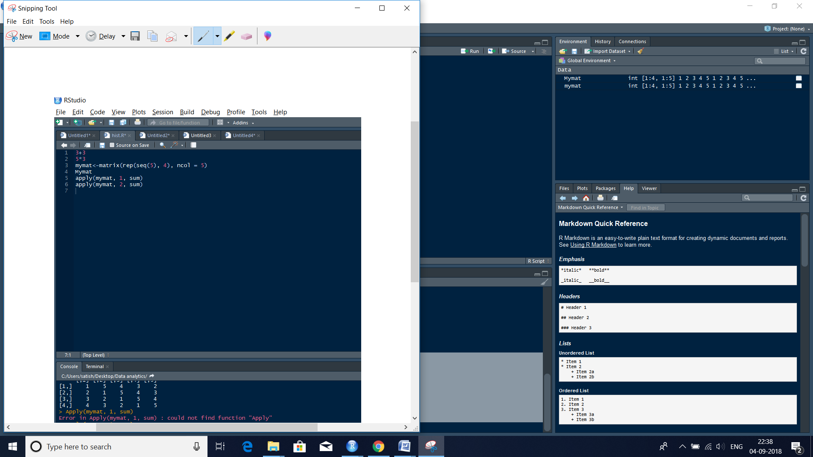

**Mymat<-matrix(rep(seq(5), 4), ncol = 5)**

**Mymat**

**Apply(mymat, 1, sum)**

**Apply(mymat, 2, sum)**

|  |
| --- |
| > mymat<-matrix(rep(seq(5), 4), ncol = 5)  > Mymat  [,1] [,2] [,3] [,4] [,5]  [1,] 1 5 4 3 2  [2,] 2 1 5 4 3  [3,] 3 2 1 5 4  [4,] 4 3 2 1 5  > apply(mymat, 1, sum)  [1] 15 15 15 15  > apply(mymat, 2, sum)  [1] 10 11 12 13 14 |
|  |
| |  | | --- | | > | |